**Unit 3 Algorithmics**

**Submit Task – Week 7**

1. Use Dijkstra’s algorithm on the following two graphs to find the shortest path between S and T. Show your working at each stage.

10

10

9

12

10

12

16

4

6

8

11

7

12

E

D

B

T

C

S

G

F

A

6

8

21

2

9

12

4

9

1

3

T

F

E

D

C

B

S

A

2. Use the Bellman-Ford algorithm to find the shortest path from S to T on the following graph. Show your working at each stage.

3

A

4

1

5

D

8

3

G

S

1

10

-3

B

6

8

T

E

-4

C

7

F

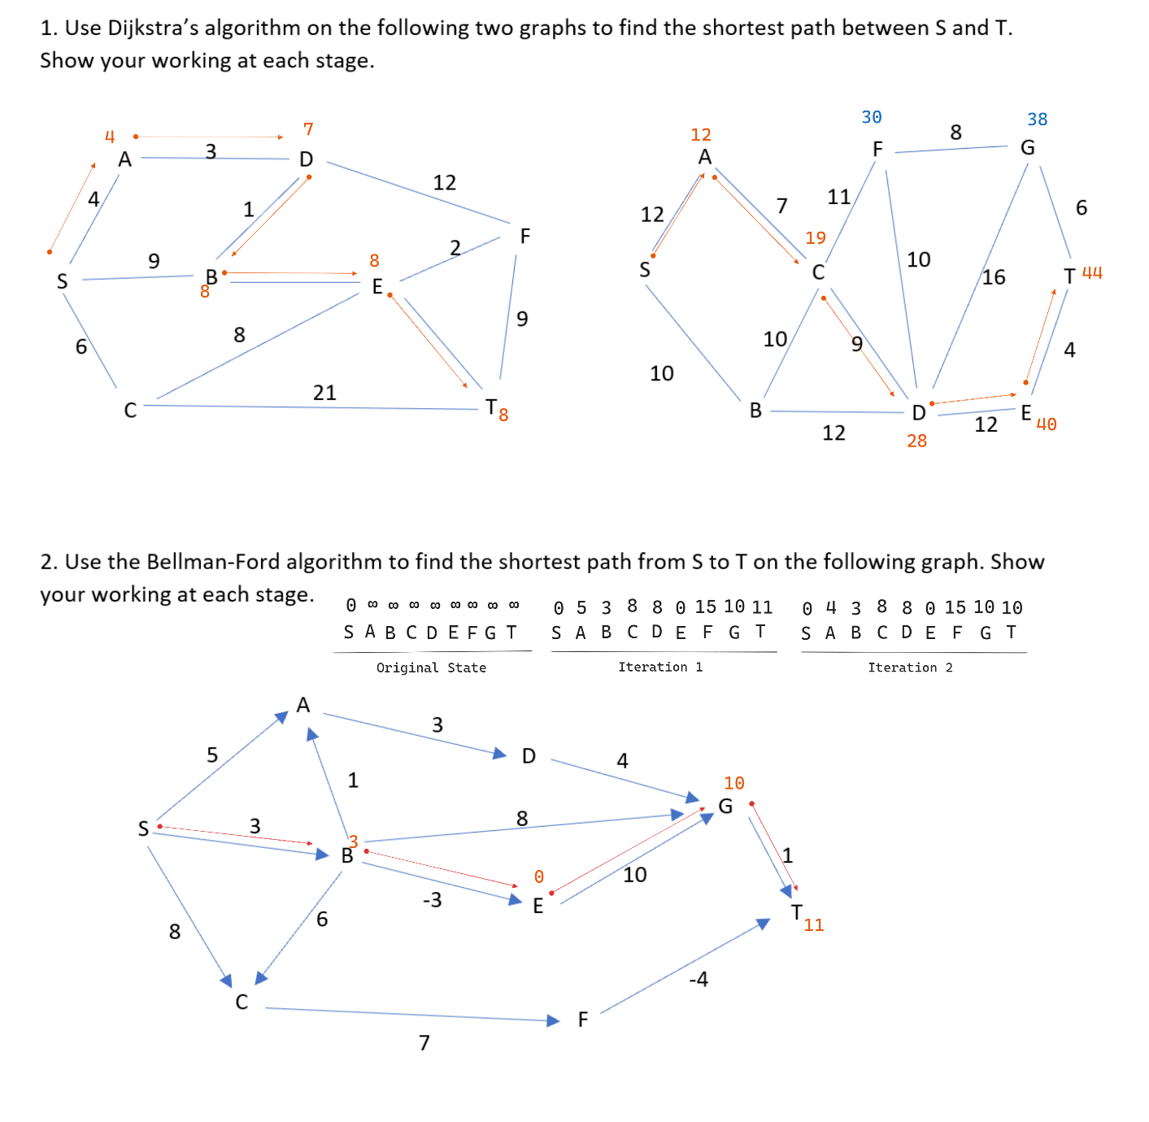

Idk if I got Bellman-Ford wrong cause I was confused about how the iterations work (I know there should be V-1 iterations but I don’t think anything changes after the second one). Typo in the 2nd iteration, T should be 11 not 10.

3. Use the template provided to construct Dijkstra’s algorithm in Python. Include comments, a PY file and a screen shot of your output.

<https://trinket.io/python3/93f80deef7>